CREATE TABLE rcb_players (

player_id INT UNSIGNED NOT NULL AUTO_INCREMENT,

player_name VARCHAR(100) NOT NULL,

role ENUM('Batsman', 'Bowler', 'All-rounder', 'Wicketkeeper', 'Wicketkeeper-Batsman') NOT NULL,

nationality VARCHAR(50) NOT NULL,

seasons_played JSON COMMENT 'Array of seasons played with RCB',

matches_played SMALLINT UNSIGNED DEFAULT 0,

runs_scored MEDIUMINT UNSIGNED DEFAULT 0,

batting_avg DECIMAL(6,2) UNSIGNED,

strike_rate DECIMAL(6,2) UNSIGNED,

wickets_taken SMALLINT UNSIGNED DEFAULT 0,

bowling_avg DECIMAL(6,2) UNSIGNED,

economy_rate DECIMAL(6,2) UNSIGNED,

highest_score TINYINT UNSIGNED,

best_bowling VARCHAR(20),

auction_price DECIMAL(8,2) UNSIGNED COMMENT 'Price in crore INR',

current_status ENUM('Active', 'Retired', 'Traded', 'Released', 'Injured'),

last_updated TIMESTAMP DEFAULT CURRENT_TIMESTAMP ON UPDATE CURRENT_TIMESTAMP,

PRIMARY KEY (player_id),

INDEX idx_player_name (player_name),

INDEX idx_role (role),

INDEX idx_nationality (nationality)

) ENGINE=InnoDB DEFAULT CHARSET=utf8mb4 COLLATE=utf8mb4_0900_ai_ci;

INSERT INTO rcb_players (

player_name, role, nationality, seasons_played, matches_played,

runs_scored, batting_avg, strike_rate, wickets_taken, bowling_avg,

economy_rate, highest_score, best_bowling, auction_price, current_status

) VALUES (

'Faf du Plessis', 'Batsman', 'South Africa', '["2022", "2023", "2024"]', 29,

1078, 39.92, 130.50, 0, NULL,

NULL, 96, NULL, 7.00, 'Active'

);

-- Insert Virat Kohli

INSERT INTO rcb_players (

player_name, role, nationality, seasons_played, matches_played,

runs_scored, batting_avg, strike_rate, wickets_taken, bowling_avg,

economy_rate, highest_score, best_bowling, auction_price, current_status

) VALUES (

'Virat Kohli', 'Batsman', 'India', '["2008", "2009", "2010", "2011", "2012", "2013", "2014", "2015", "2016", "2017", "2018", "2019", "2020", "2021", "2022", "2023", "2024"]', 237,

7263, 37.25, 130.02, 4, 94.25,

8.71, 113, '1/7', 15.00, 'Active'

);

-- Insert Glenn Maxwell

INSERT INTO rcb_players (

player_name, role, nationality, seasons_played, matches_played,

runs_scored, batting_avg, strike_rate, wickets_taken, bowling_avg,

economy_rate, highest_score, best_bowling, auction_price, current_status

) VALUES (

'Glenn Maxwell', 'All-rounder', 'Australia', '["2021", "2022", "2023", "2024"]', 47,

1278, 32.00, 157.62, 15, 35.20,

8.45, 78, '2/15', 11.00, 'Active'

);

-- Insert Mohammed Siraj

INSERT INTO rcb_players (

player_name, role, nationality, seasons_played, matches_played,

runs_scored, batting_avg, strike_rate, wickets_taken, bowling_avg,

economy_rate, highest_score, best_bowling, auction_price, current_status

) VALUES (

'Mohammed Siraj', 'Bowler', 'India', '["2018", "2019", "2020", "2021", "2022", "2023", "2024"]', 73,

46, 4.60, 85.19, 78, 27.95,

8.54, 12, '4/21', 7.00, 'Active'

);

-- Insert Cameron Green

INSERT INTO rcb_players (

player_name, role, nationality, seasons_played, matches_played,

runs_scored, batting_avg, strike_rate, wickets_taken, bowling_avg,

economy_rate, highest_score, best_bowling, auction_price, current_status

) VALUES (

'Cameron Green', 'All-rounder', 'Australia', '["2024"]', 0,

0, NULL, NULL, 0, NULL,

NULL, 0, NULL, 17.50, 'Active'

);

-- Insert Alzarri Joseph

INSERT INTO rcb_players (

player_name, role, nationality, seasons_played, matches_played,

runs_scored, batting_avg, strike_rate, wickets_taken, bowling_avg,

economy_rate, highest_score, best_bowling, auction_price, current_status

) VALUES (

'Alzarri Joseph', 'Bowler', 'West Indies', '["2024"]', 0,

0, NULL, NULL, 0, NULL,

NULL, 0, NULL, 11.50, 'Active'

);

-- Insert Dinesh Karthik

INSERT INTO rcb_players (

player_name, role, nationality, seasons_played, matches_played,

runs_scored, batting_avg, strike_rate, wickets_taken, bowling_avg,

economy_rate, highest_score, best_bowling, auction_price, current_status

) VALUES (

'Dinesh Karthik', 'Wicketkeeper-Batsman', 'India', '["2015", "2022", "2023", "2024"]', 56,

876, 26.54, 147.47, 0, NULL,

NULL, 97, NULL, 5.50, 'Active'

);

-- Insert Rajat Patidar

INSERT INTO rcb_players (

player_name, role, nationality, seasons_played, matches_played,

runs_scored, batting_avg, strike_rate, wickets_taken, bowling_avg,

economy_rate, highest_score, best_bowling, auction_price, current_status

) VALUES (

'Rajat Patidar', 'Batsman', 'India', '["2021", "2022", "2023", "2024"]', 23,

749, 35.66, 147.53, 0, NULL,

NULL, 112, NULL, 0.20, 'Active'

);

-- Insert Mayank Dagar

INSERT INTO rcb_players (

player_name, role, nationality, seasons_played, matches_played,

runs_scored, batting_avg, strike_rate, wickets_taken, bowling_avg,

economy_rate, highest_score, best_bowling, auction_price, current_status

) VALUES (

'Mayank Dagar', 'All-rounder', 'India', '["2024"]', 0,

0, NULL, NULL, 0, NULL,

NULL, 0, NULL, 1.80, 'Active'

);

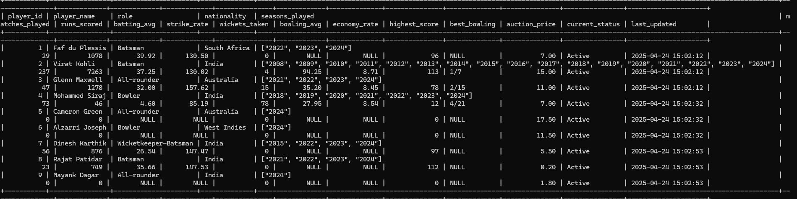

-- Find all active batsmen

SELECT player_name, batting_avg, strike_rate

FROM rcb_players

WHERE role = 'Batsman' AND current_status = 'Active';

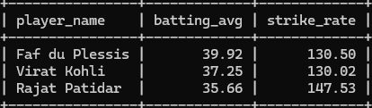

-- Get players sorted by highest auction price

SELECT player_name, auction_price

FROM rcb_players

ORDER BY auction_price DESC;

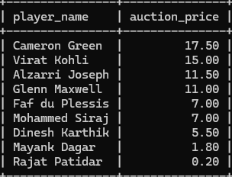

-- Average batting stats by player role

SELECT

role,

AVG(batting_avg) AS avg_batting,

AVG(strike_rate) AS avg_strike_rate

FROM rcb_players

WHERE batting_avg IS NOT NULL

GROUP BY role;

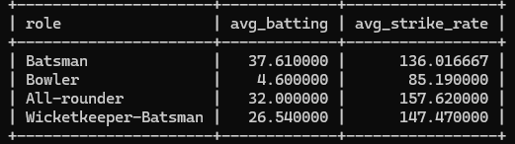

-- Find players who joined in 2024 using JSON functions

SELECT player_name, seasons_played

FROM rcb_players

WHERE JSON_CONTAINS(seasons_played, '"2024"');

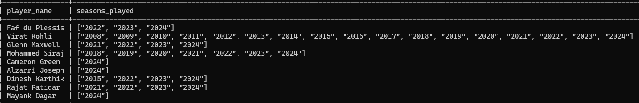

SELECT

player_name,

runs_scored,

batting_avg,

strike_rate,

auction_price,

ROUND((runs_scored/auction_price), 2) AS runs_per_crore,

ROUND((batting_avg/auction_price), 2) AS avg_per_crore,

ROUND((strike_rate/auction_price), 2) AS sr_per_crore

FROM rcb_players

WHERE runs_scored > 0 AND auction_price > 0

ORDER BY runs_per_crore DESC;

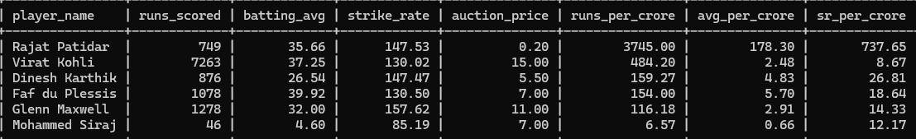

SELECT player_name, seasons_played

FROM rcb_players

WHERE JSON_CONTAINS(seasons_played, '["2023", "2024"]');

